July 2025
Rittal Appoints New Country Manager to Lead its Irish Operations
Rittal, a leading global supplier of enclosure systems, automation and infrastructure solutions for industrial and IT applications, has appointed Jim Murray as Country Manager for its Irish operations.
With more than 25 years’ experience in the electrical and industrial sectors, Jim brings a wealth of knowledge, hands-on expertise, and a knowledge of strategic leadership within highly competitive markets.
He started his career at a major distributor of low-voltage products before joining Rittal seven years ago, rapidly progressing from Area Sales Manager to Sales Director, and now Country Manager. He credits his experience as having helped shape his understanding of the Irish industrial landscape and honing his ability to build high-performing, customer-centric teams.
Jim advises, “I’m delighted to have been appointed as Rittal’s Country Manager in Ireland, as well as the Irish lead for IT and IE for the Central Europe cluster. The latter means I can zoom out and take a more global look at trends and markets, rather than just a local view.
His immediate priorities include strengthening strategic partnerships, expanding the company’s turnkey solution offering, and helping customers tackle challenges in areas such as sustainability and supply chain resilience.
He explains, “Rittal doesn’t just sell enclosures; we sell solutions. We’re experts in power distribution, cooling, customisation, as well as smart infrastructure and we offer specialist technical insight to help our customers solve real-world problems.
“We’ve got a key competitive edge with our modification centre based here in Ireland. It means we can offer built-in accessories and minimal packaging, and we can do it quickly. That helps customers meet sustainability targets and maintain their operational efficiency.”
“Meanwhile, our global manufacturing facilities ensure that our multi-national customers can be always assured of the same high standards of quality and service as elsewhere in the world.
Despite the current economic and geopolitical uncertainty, Jim is optimistic about the future.
“We are well positioned to support growing opportunities in renewables and AI-driven infrastructure as Ireland transitions to a lower-carbon, data-driven economy.
“Plus, I lead a capable and committed team who work hard to deliver outstanding customer service and support. We are wholly focused on being a trusted partner to our customers, providing technical insight and products that are future-ready. Our value is in what we enable our customers to achieve.”
Ends

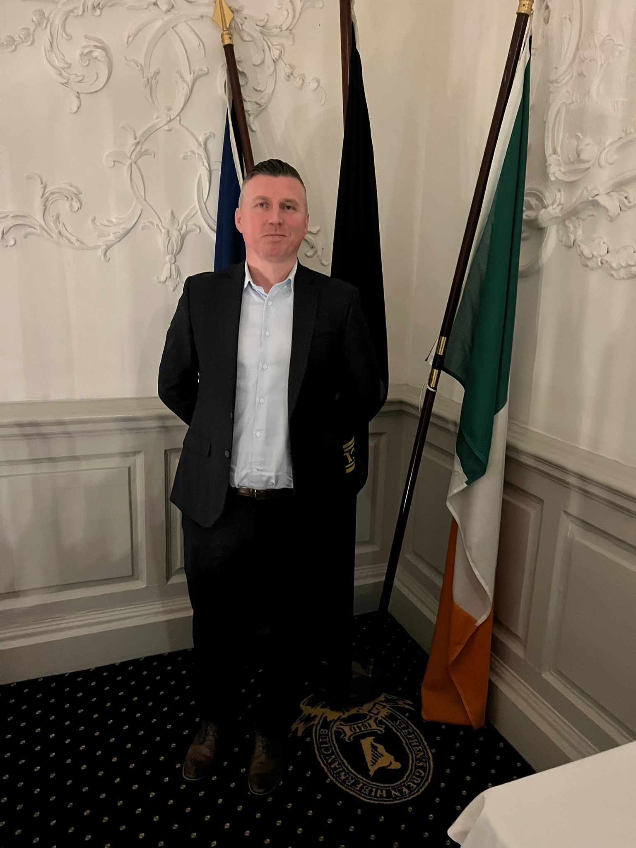
Image 1
Jim Murray – Country Manager, Rittal Ltd Ireland

Reproduction free of charge
Please specify “Rittal Ltd Ireland” as the source
Please send us a reference copy

About Rittal – notes to Editors
Rittal, headquartered in Herborn, Germany, is a leading global provider of solutions for industrial enclosures, power distribution, climate control and IT infrastructure, as well as software and services. Systems made by Rittal are deployed in over 90 per cent of all industries across the world, including mechanical and plant engineering, food and beverages, and IT and telecommunications.

The international market leader’s product portfolio includes configurable enclosures, with data available across the entire production process. Smart Rittal cooling systems, with up to 75 per cent lower power and a great CO2 advantage can communicate with the production landscape, enabling predictive maintenance and servicing. The offering also includes innovative IT products, from IT racks and modular data centres, to edge and hyperscale computing solutions.
Leading software providers Eplan and Cideon support the value chain, providing interdisciplinary engineering solutions, while Rittal Automation Systems offers solutions for switchgear. Within Germany, Rittal can supply products on demand within 24 hours – with precision, flexibility and efficiency
Founded in 1961, Rittal is the largest company in the owner-operated Friedhelm Loh Group. The Friedhelm Loh Group is active worldwide, with 12 production sites and 94 international subsidiaries. It has 11,600 employees and posted revenues of Euro 2.6 billion in fiscal 2019. In 2021, the family-run business was named one of Germany's leading employers by the Top Employers Institute, for the 13th year running. A Germany-wide survey by Focus Money magazine named Friedhelm Loh Group as one of the nation’s top companies in terms of vocational training for the fifth year running in 2021
For more information www.rittal.ie and www.friedhelm-loh-group.com

